
Foundation University Islamabad
School of Science and Technology

Name: Hunaina Yasir Roll Number: 073
Subject: OOP LAB Section: B
LAB REPORT NO.4
TASK 1:
Design a C++ program that demonstrates single inheritance by creating a base class named Employee and a derived class named Manager. The Employee class should have private data members to store the employee ID and name. It should also include a parameterized constructor to initialize these attributes and a function to display the employee's details. The Manager class should inherit from Employee and include an additional private data member for the department name. It should also have a parameterized constructor to initialize both the inherited and new attributes. Additionally, implement a function in the Manager class to display all details, including the employee ID, name, and department. In the main() function, create an object of the Manager class, initialize it using a constructor, and display the manager's details using the appropriate function.

SOURCE CODE:
#include <iostream>
#include <string>
using namespace std;

class Employee {
private:
int id;
string name;

public:
Employee(int empId, string empName) {
id = empId;
name = empName;
}

void displayEmployee() {
cout << "ID: " << id << endl;
cout << "Name: " << name << endl;
}
};

class Manager : public Employee {
private:
string department;

public:
Manager(int empId, string empName, string dep) : Employee(empId, empName) {
department = dep;
}

void displayAllDetails() {
displayEmployee();
cout << "Department: " << department << endl;
}
};

int main() {
Manager m1(101, "Alice", "IT Operations");
m1.displayAllDetails();

return 0;
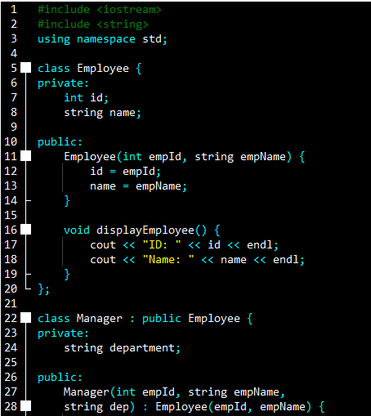
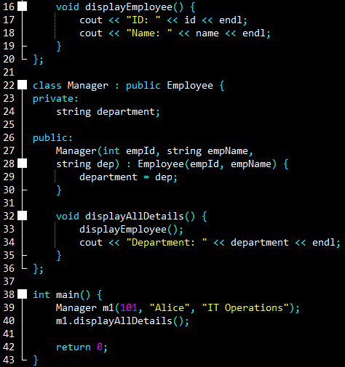
}

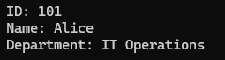
OUTPUT:
ID: 101
Name: Alice
Department: IT Operations

TASK 2:
Create a C++ program that demonstrates single inheritance by defining a base class Vehicle and a derived class Car. The Vehicle class should contain private data members to store the vehicle brand and model year. It should include a parameterized constructor to initialize these attributes and a function to display the vehicle's details. The Car class should inherit from Vehicle and have an additional private data member for the fuel type (e.g., petrol, diesel, electric). The Car class should also include a parameterized constructor that initializes all attributes, including those inherited from Vehicle. Additionally, implement a function in the Car class to display all details, including the brand, model year, and fuel type. In the main() function, create an object of the Car class, initialize it using a constructor, and display the car’s details using the appropriate function.

SOURCE CODE:
#include <iostream>
#include <string>
using namespace std;

class Vehicle {
private:
string brand;
int year;

public:
Vehicle(string b, int y) {
brand = b;
year = y;
}

void displayVehicle() {
cout << "Brand: " << brand << endl;
cout << "Year: " << year << endl;
}
};

class Car : public Vehicle {
private:
string fuelType;

public:
Car(string b, int y, string fuel) : Vehicle(b, y) {
fuelType = fuel;
}

void displayCarDetails() {
displayVehicle();
cout << "Fuel Type: " << fuelType << endl;
}
};

int main() {
Car myCar("Toyota", 2022, "Hybrid");
myCar.displayCarDetails();

return 0;
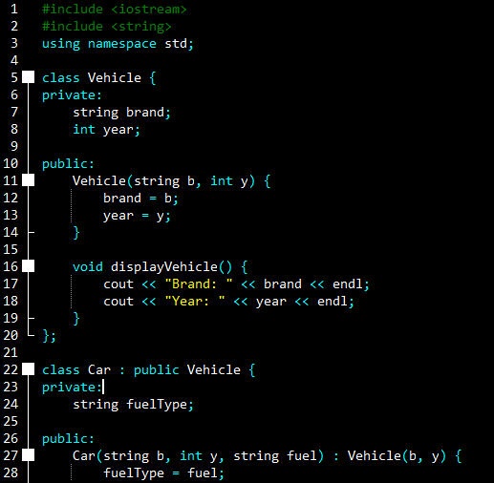
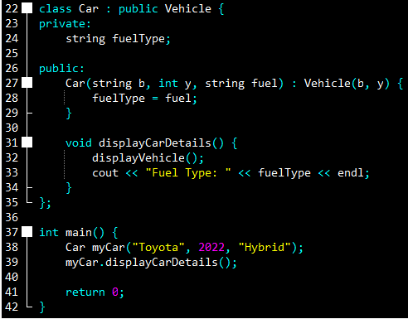
}

OUTPUT:
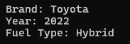
Brand: Toyota
Year: 2022
Fuel Type: Hybrid

TASK 3:
Write a C++ program that demonstrates single inheritance by creating a base class
Student and a derived class Graduate. The Student class should have private data members for the student's roll number and name. It should include a parameterized constructor to initialize these attributes and a function to display the student’s details. The Graduate class should inherit from Student and include an additional private data member for the degree program (e.g., BS Computer Science, MBA, etc.). The Graduate class should have a parameterized constructor that initializes both the inherited and new attributes. Implement a function in the Graduate class to display all details, including the roll number, name, and degree program. In the main() function, create an object of the Graduate class, initialize it using a constructor, and display the graduate’s details using the appropriate function.

SOURCE CODE:
#include <iostream>
#include <string>
using namespace std;

class Student {
private:
int rollNo;
string name;

public:
Student(int r, string n) {
rollNo = r;
name = n;
}

void showStudent() {
cout << "Roll Number: " << rollNo << endl;
cout << "Student Name: " << name << endl;
}
};

class Graduate : public Student {
private:
string degree;

public:
Graduate(int r, string n, string d) : Student(r, n) {
degree = d;
}

void showFullDetails() {
showStudent();
cout << "Degree Program: " << degree << endl;
}
};

int main() {
Graduate g1(505, "John Doe", "BS Computer Science");
g1.showFullDetails();

return 0;
}
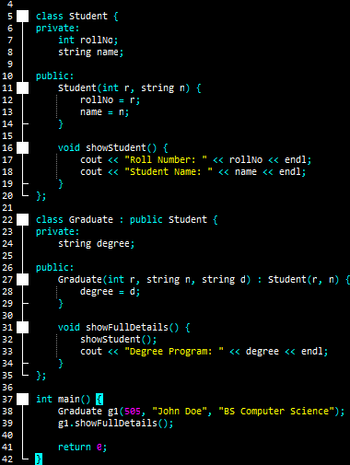
OUTPUT:
Roll Number: 505
Student Name: John Doe
Degree Program: BS Computer Science
